Team Friday

**Project:** AVA, <http://theback.space:8000/>

**Features of Ava:**

-*Register or Log on*: A customer may decide to create an account with Ava. This is beneficial to the customer because it allows him/her to save or bookmark recipes they have found as well as save ingredients that they have inputted to their pantry to use for next time.

-*Add ingredients to your pantry*: A customer can add ingredients to their pantry by clicking on icons or typing in specific ingredients. The pantry will slide open like a drawer when the customer wants to use it. The pantry stores the ingredients so the customer knows what he/she has already as well as ingredients they do not have.

-*Search for a recipe*: The customer can type their query directly into the text box to search for a recipe they want to make. For example, “pasta dinner with tomatoes”. Ava will locate recipes that match the description and pop up a recipe towards the left of the website displaying the recipe title, an image, ingredients required, and steps needed to make the recipe.

-*Save or bookmark recipes*: Customers who are registered will be able to save recipes to view them later. A customer with an account will also be able to save the ingredients that they inputted to the pantry to use for future searches and recipes.

-*Leave a rating or feedback response*: Customers who have an account will be able to leave a star rating for recipes that they have tried and also leave specific feedback or suggestions that other users will be able to see.

**Requirements to run the system**: basic internet knowledge

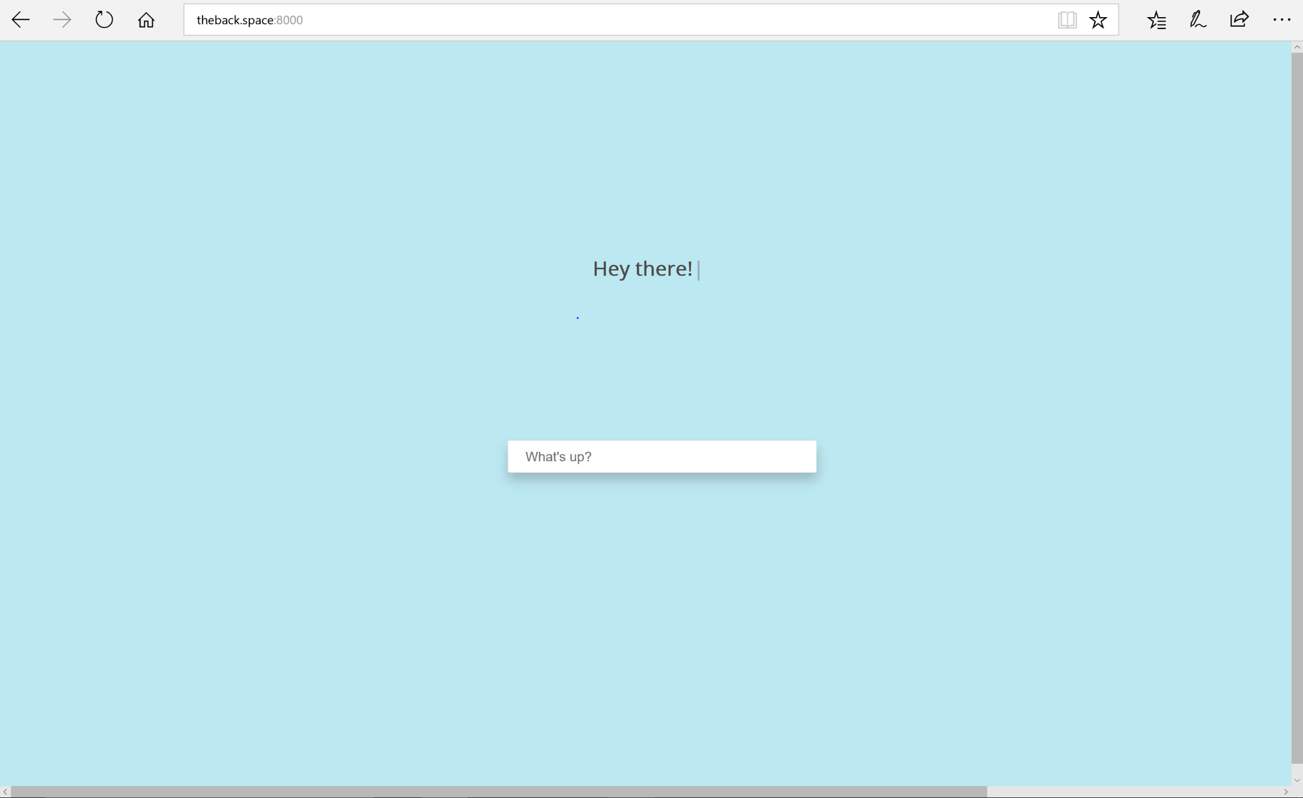

**RECIPE**



The pantry slides down with a drop down menu when you want to access it

This is where Ava’s response will display

This is where you type what you want to accomplish. EX: search for a recipe, sign up, log in…

This is where your text will display after you submit it